JOS: Reading a Feed Tag
Unit: Animal Nutrition
Tools & Materials: Various feed tags from livestock feed intended for different species, various livestock species feedbags/minerals

Objectives:
- Fully describe those items that must be included on a feed tag as required by law using the JOS
- Compare and contrast feed rations for 3 different species of livestock with help from the JOS

Steps of Procedure | Key Points | Illustrations
Obtain Feed Tag | Tags are usually attached to the bag or item (taped)  Some tags are printed on the bag
Identify Net Weight | Net weight is the weight of the finished product not including the bag  This number is usually present on the bag
Identify Brand Name | The brand name indicates the maker of the product | 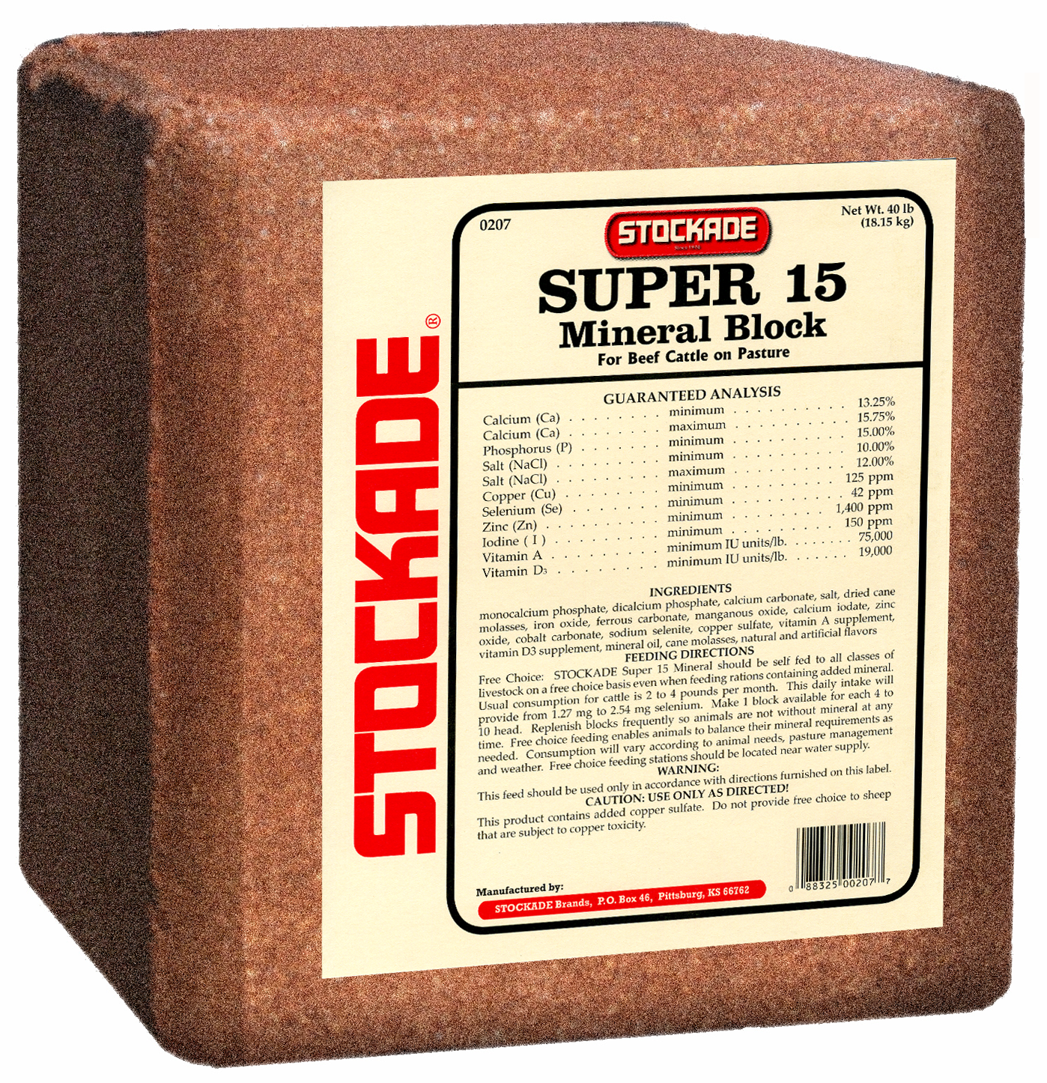
Identify Manufacture Information | The manufacture is the one who distributes the product for the brand  It is important to know the name and address of the manufacture to know where your item is coming from
Identify the Name of Each Ingredient | Ingredients are usually listed at the bottom of the tag  They are usually listed in order of most abundant to least used in the product
Identify the Guaranteed Analysis | Provides basic nutritional values;  Minimum percentage of crude protein  Minimum percentage of crude fat  Maximum percentage of crude fiber  The analysis contained on the feed tag is determined by chemical means. The chemical analysis indicates the percentage of each nutrient contained in that particular feed.  Not all of the nutrients are usable by the animal, since not all of the nutrients are in a digestible form.
Identify Mineral Feed Contents | Mineral feeds must include;  Minimum percentage of salt, calcium, phosphorus, and iodine  Maximum percentage of salt and calcium

Student Evaluation Name: _____________________
Job: Reading a Feed Tag Date: ______________________

Task | Student Evaluation | Instructor Evaluation
Obtained a legible feed tag for livestock use (2 points)
Identified the net weight
(2 points)
Identified the brand name
(2 points)
Identified manufacture information, name and address
(2 points)
Identified ingredients
(2 points)
Identified the guaranteed analysis
- Minimum percentage of crude protein
- Minimum percentage of crude fat
- Maximum percentage of crude fiber
(5points)
Identified mineral content for a mineral feed (5points)
Compared feed labels for 3 different livestock species (5points)
Total (25 points)

